MULTIPLE SOCKET CONTROL OUTPUT:

1.charging from Socket 1

Note: Code for socket 1 =a1bc

Code for socket2=a2bc

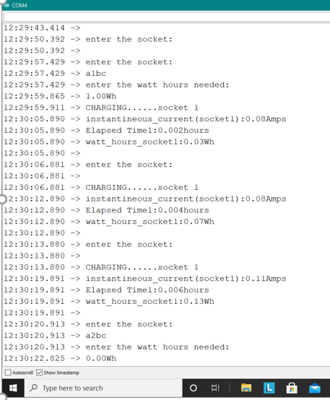

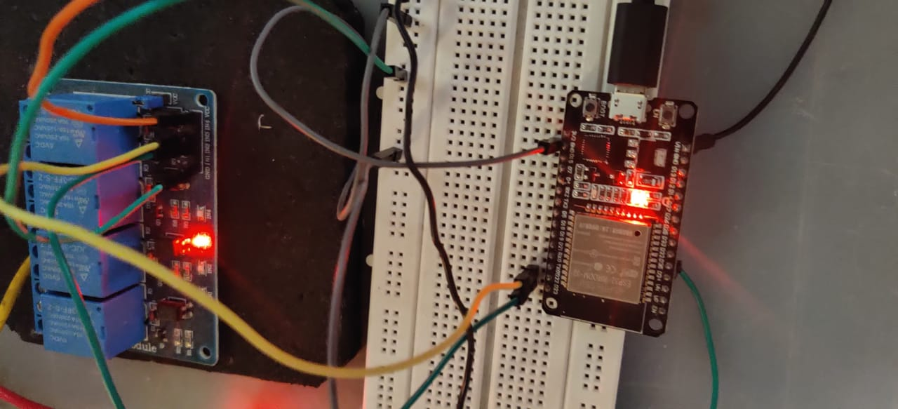

2.Charging from socket 2

Note: since I have given 0 Wh as input it will turn off within a second.

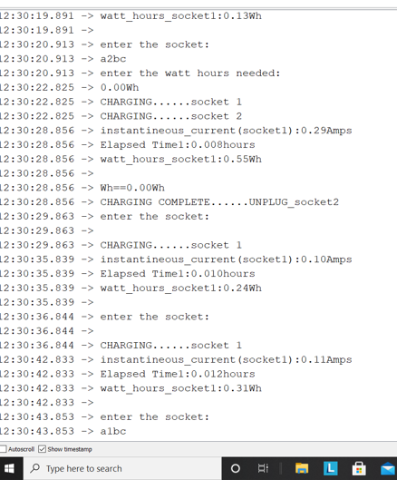

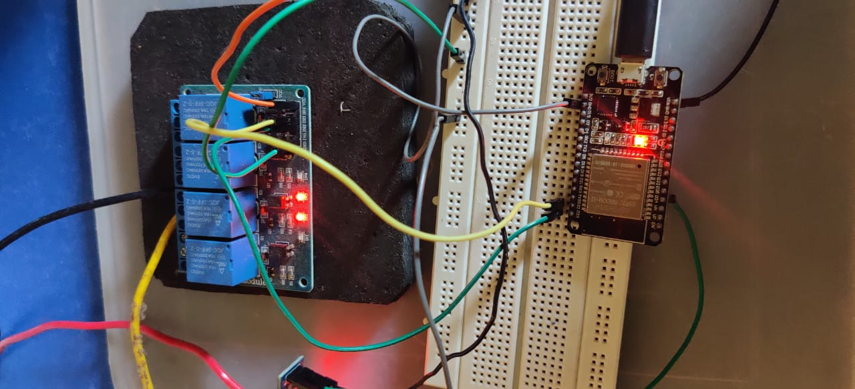

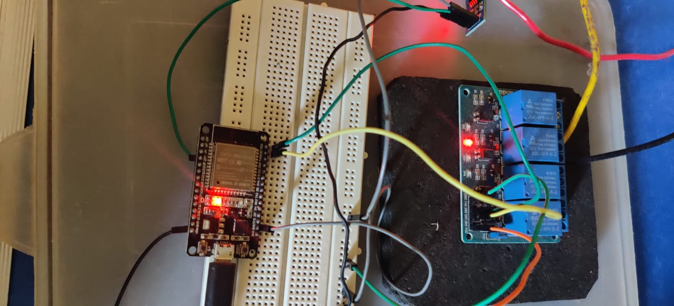

3.try to access a busy socket .

Here since socket 1 is busy, if we try to access it again we will get

“socket 1 is busy”

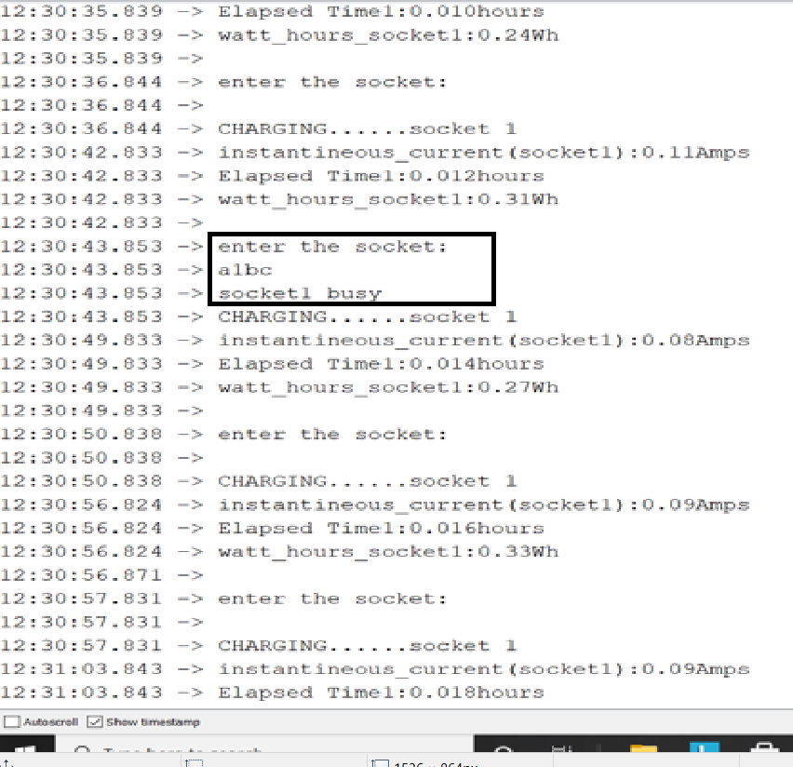

4.after complete charging the socket one is released.

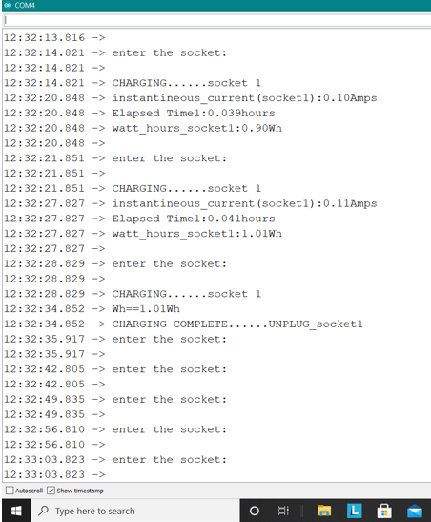

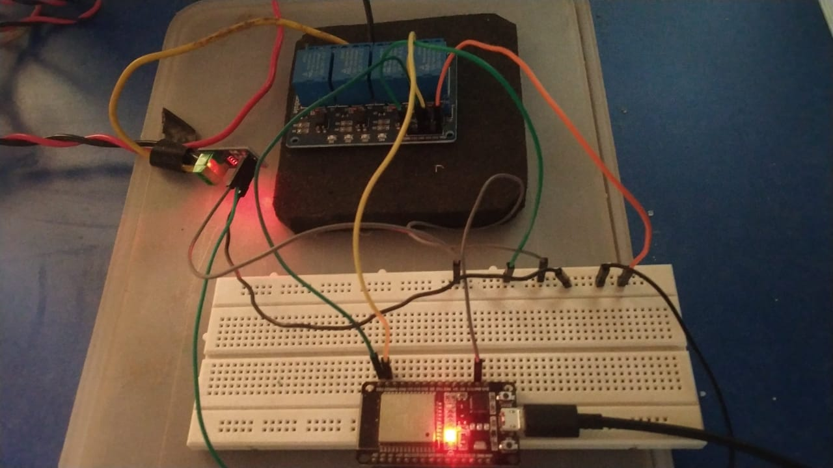

WRONG socket code : if user enters a wrong socket code ,it is ignored .

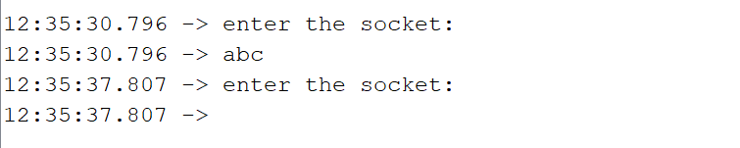

INPUT :

